

**Task 14: Rate of Reaction and Gas Laws Topic Test**

**Question/Answer Booklet**

**CHEMISTRY UNIT 2**

Student Name: _____________________________________

Teacher’s Name: _____________________________________

# **TIME ALLOWED FOR THIS PAPER**

Reading time for the paper: 5 minutes

Working time for the paper: 45 minutes

# **MATERIALS REQUIRED/RECOMMENDED FOR THIS PAPER**

**To be provided by the supervisor:**

This Question/Answer Booklet

Chemistry Data Book

**To be provided by the candidate:**

Standard items: pens (blue/black preferred), pencils (including coloured), sharpener, eraser, correction tape/fluid, ruler, highlighters

Special items: up to three non-programmable calculators approved for use in the WACE examinations

# **IMPORTANT NOTE TO CANDIDATES**

No other items may be taken into the examination room. It is **your** responsibility to ensure that you do not have any unauthorised notes or other items of a non-personal nature in the examination room. If you have any unauthorised material with you, hand it to the supervisor **before** reading any further

**Multiple Choice Section 15 marks**

1. Why does reaction rate increase as temperature increases?

a) The activation energy is lowered.  
b) There are more particles at higher temperatures so more of them collide.  
c) Particles move faster and this increases the probability of collision.  
d) Particles require a set temperature in which to begin colliding.

1. Which of the following changes would **not** change the initial rate of reaction between zinc and dilute nitric acid?

a) the addition of a catalyst.

b) a change in the temperature of the reactants.

c) using double the volume of the nitric acid

d) breaking down the zinc into smaller pieces

1. Many chemical reactions that are carried out in aqueous solution proceed more slowly if the system is further diluted. This is most likely due to:

a) a change in the nature of the reactants.

b) a change in the surface area of the reactants.

c) a change in the concentration of the reactants.

d) a change in temperature.

1. Which one of the following sets of conditions is likely to cause the decomposition of hydrogen peroxide into water and oxygen gas to occur most rapidly?

2H2O2 🡪 2H2O + O2

a) High concentration of reactants, low temperature

b) Low concentration of reactants, high temperature

c) Low concentration of reactants, low temperature

d) High concentration of reactants, high temperature

1. What is the role of a catalyst in a chemical reaction?

a) To provide an alternate pathway for the reaction that is faster than the original

b) To produce a greater enthalpy change, thus speeding up the reaction

c) To increase the rate of the forward reaction only

d) to increase the rate of the reverse reaction only

1. The diagram represents the energy curve for the reaction

C(s) + O2(g) plainarrow.gifCO2(g)

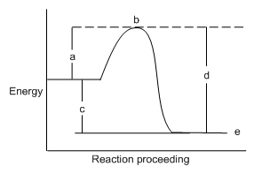  
Which letter shows the energy of the transition state of the reaction?

a) a

b) b

c) c

d) d

1. The diagram represents the energy profile diagram for the reaction.

N2(g) + 2 O2(g) plainarrow.gif2 NO2(g)

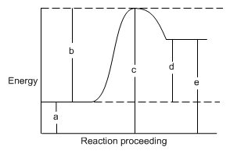

Which letter corresponds to the activation energy for this reaction?

1. a
2. b
3. c
4. d
5. Which statement is true about energy in this reaction?

CH4 + 2O2 🡪 2H2O + CO2 + heat

a) The reaction is exothermic because it releases heat.

b) The reaction is exothermic because it absorbs heat.

c) The reaction is endothermic because it releases heat.

d) The reaction is endothermic because it absorbs heat.

1. Potassium permanganate is a purple solution that decolourises when it reacts with excess oxalic acid according to the ionic equation:



Which of the following is true?

a) When production of carbon dioxide bubbles ceases, there are no reactants left.

b) The faster the bubbles are given off, the slower the rate of reaction.

c) The lighter the colour of the solution, the greater the rate of reaction.

d) The lighter the colour of the solution, the lower the concentration of the reactants.

1. Which arrow in the diagram above represents the Activation Energy for the **reverse** reaction?

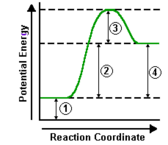

a) 1 + 2 + 3

b) 2 + 3

c) 3

d) 4

1. Which of the following statements is **incorrect** in regards to metallic nanoparticle catalysts.
   1. They are resistant to their environment
   2. They increase the rate of reaction
   3. Are used in cars to convert toxic gases to less harmful products
   4. They can be used for a large variety of reactions
2. Which of the following will **not** change the total volume of a gas?
   1. The number of particles
   2. The pressure of the gas
   3. The molecular weight of particles
   4. They will all change the volume of a gas
3. In a particular engine, 3.102 L of propane is allowed to combust completely with oxygen at standard temperature and pressure. What is the volume of carbon dioxide gas produced?

a) 6.204 L  
b) 9.306 L  
c) 3.102 L  
d) 1.551 L

1. A gas was produced in a chemical reaction. The total volume of gas formed was measured at regular time intervals. **Which graph would you expect the results to be like**?

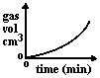 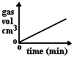 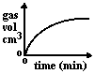 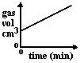

A B C D

a) A

b) B

c) C

d) D

1. Which of the following statements is **not** correct regarding an ideal gas?
2. The volume of 1 mole of an ideal gas at STP is 22.71 litres.
3. The volume of 1 mole of an ideal gas at absolute zero is 0 litres.
4. The particles of an ideal gas are weakly attracted to one another.
5. The average kinetic energy of ideal gas particles is proportional to temperature.

**Short Answer Section 30 marks**

1. According to Collision theory, what three things are required for a chemical reaction to occur?

[3 marks]

1. Carbon dioxide gas can easily be prepared in the lab by adding hydrochloric acid to marble chips (calcium carbonate). How many litres of gas (at STP) would be produced from 50.0g of Calcium carbonate?[3 marks]
2. List three ways in which this reaction could be made to go faster.[3 marks]

(There is no catalyst for this reaction!)

1. Explain, using collision theory, **how** one of these would increase the rate of reaction. [3 marks]
2. For each of the following situations, state how the second variable will change.[3 marks]
   1. If temperature increases, volume will **increase / decrease**
   2. If the volume is decreased, pressure will **increase / decrease**
   3. If the amount of mole is increased, pressure will **increase / decrease**

Examine the energy profile diagram for a reaction and use it to answer the following questions (6-9).

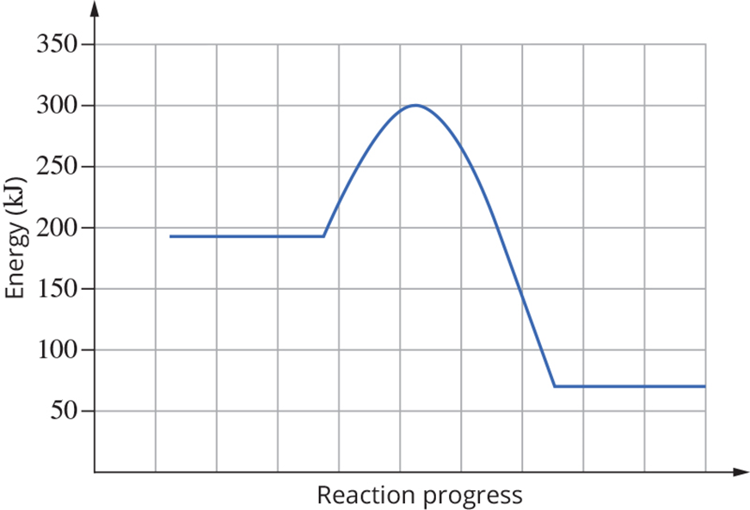

1. On the diagram add the following:

Label the **enthalpy change(∆H), transition state**, **activation energy**.[3 marks]

Draw a curve on the set of axes to show the energy profile if a catalyst is used.[1 mark]

1. State whether the diagram represents an exothermic or endothermic reaction. [1 mark]
2. What is the value of the enthalpy change for the forward reaction?[1 mark]
3. What is the value of the activation energy for the forward reaction?[1 mark]
4. 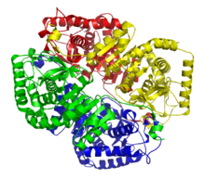Glucose is the main source of energy used by living cells. In the human body, glucose, C6H12O6 is obtained from the digestion of carbohydrates and is stored in the liver as a polysaccharide called glycogen, (C6H12O6)n. A simplified equation for the conversion of glucose to glycogen is represented here.

**enzyme**

nC6H12O6 (C6H12O6)n

* 1. What is the **role** of the enzyme shown in the equation? [1 mark]
  2. In the equation above, the enzyme is written above the arrow. Why isn’t it included as a reactant or product?[1 mark]

1. There is carbon dioxide in a 30 L container exerting a pressure of 150kPa at 25°C.

A separate 30L container contains nitrogen gas at 150kPa and 25°C.

Circle the correct response.[3 marks]

The mass of gas in the two containers will be the same **True / False**

The number of molecules will be the same **True / False**

The number of atoms of nitrogen will be **greater / the same / less than** the number of atoms of carbon

1. A balloon containing 3.0 L of gas is taken from standard temperature and pressure, and placed in a vat of liquid nitrogen. With reference to the kinetic theory of gas, explain what will happen to the size of the balloon.[3 marks]